PETS IN TURKEY
Chemin François Rossiaud 4, 1247 Anieres Switzerland
info@petsinturkey.org @petsinturkey

Application form - CAT
Please do not feel offended by some of our questions. We just want to make sure, our rescued pets fit in with their new families to give them the best possible start in their new lives.
Last name:
First name:
Date of birth:
Adress:
Zip code / location:
Country:
Phone number (Mobile):
Email address:
Which cat are you applying for?
________________________________________________
Do you live in an apartment or house?
________________________________________________
Is there a written consent of the landlord?
________________________________________________
Do you have a garden?
________________________________________________
How many people are living in the household?
________________________________________________
Number of children? And ages?
________________________________________________
Are your children aware how to handle cats?
________________________________________________

If your family planning is not finished yet, are you ready to keep
the animal and let your children grow up with?
________________________________________________
Is a move planned in the near future?
________________________________________________
Are all family members in agreement with the cat?
________________________________________________
Cat related allergies in the family?
________________________________________________
Do you already have pets?
________________________________________________
Did you already have pets in the past?
________________________________________________
Do you have a support system for the cat while you go away? (A friend or a family member feeding him etc.)
________________________________________________
Have you ever had a rescued pet before?
________________________________________________
Do you agree with a face to face videochat?
________________________________________________

Thank you very much for your time!

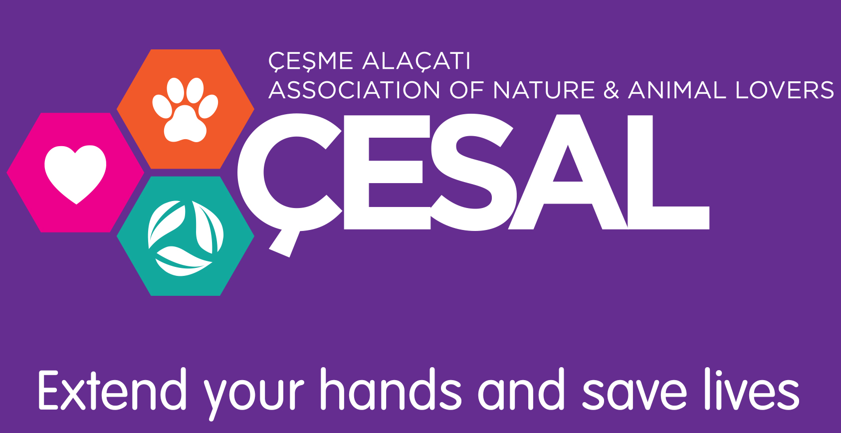
We support ÇESAL
www.cesal.org.tr

