PETS IN TURKEY
Chemin François Rossiaud 4, 1247 Anieres Switzerland
info@petsinturkey.org @petsinturkey

Application form - DOG
Please do not feel offended by some of our questions. We just want to make sure, our rescued dogs fit in with their new families to give them the best possible start in their new lives.
Last name:
First name:
Date of birth:
Adress:
Zip code / location:
Country:
Phone number (Mobile):
Email address:
Which dog are you applying for?
________________________________________________
Do you live in an apartment or house?
________________________________________________
Is there a written consent of the landlord?
________________________________________________
Do you have a garden? If yes, how big is your garden?
________________________________________________
Is your garden fenced? Height?
________________________________________________
How many people are living in the household?
________________________________________________
Number of children? And ages?
________________________________________________
Are your children aware how to handle dogs?
________________________________________________
If your family planning is not finished yet, are you ready to keep the animal and let your children grow up with?
________________________________________________
Is a move planned in the near future?
________________________________________________
Are all family members in agreement with the dog?
________________________________________________
Dog related allergies in the family?
________________________________________________
How long do you have effective time for the dog during the day?
________________________________________________
Do you already have pets?
________________________________________________
How long does your pet have to stay alone every day?
________________________________________________
Do you have an alternative/ backup plan if your animal can not stay alone?
________________________________________________
Did you already have dogs in the past?
________________________________________________
How is your holiday planned (with dog or without)?
________________________________________________
Do you plan to take some days off when the dog comes for a smooth transition?
________________________________________________
Have you ever had a rescued pet before?
________________________________________________
Do you agree with a face to face videochat?
________________________________________________

Thank you very much for your time!

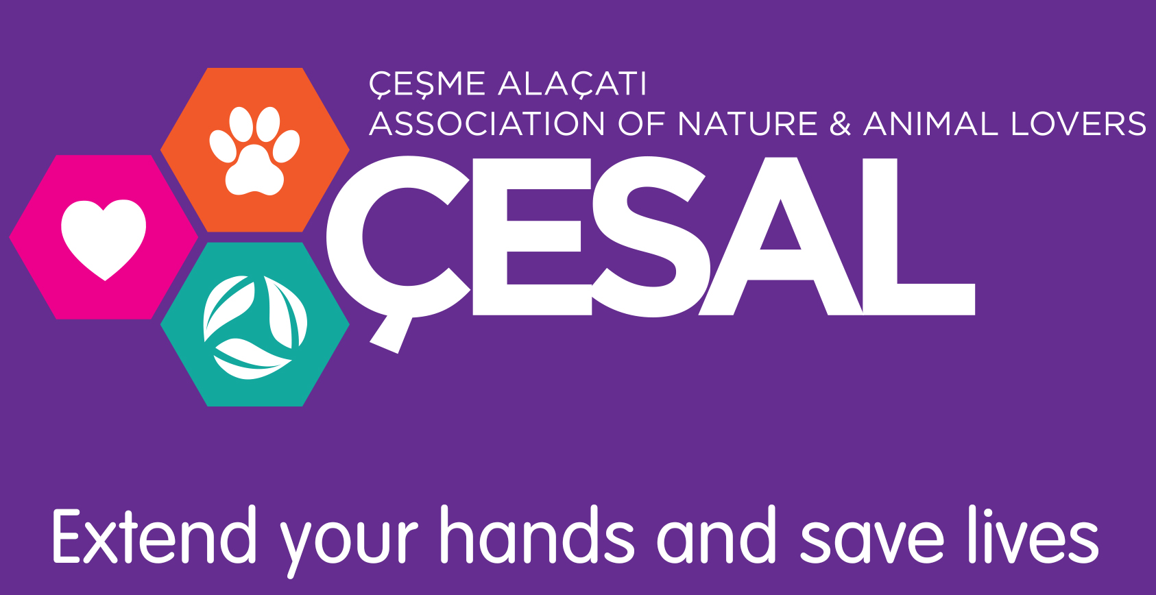
We support ÇESAL
www.cesal.org.tr

